DAY 3

1.     (i) Write a function in R programming to print generate Fibonacci sequence using    
  
  
     Recursion in R  
 .  
  
(ii) Find sum of natural numbers up-to 10, without formula using loop  
  
       statement.  
  
(iii) create a vector 1:10 and Find a square of each number and store that in a  
separate list.  
  
  
2.      
(motor trend car road test) comprises fuel  
consumption, performance and                           
  
  
10 aspects of automobile  
design for 32 automobiles. It comes pre-installed  with  package in R.  
  
  
                (i)Find the dimension of the data  
se  
  
  
                (ii)Give the statistical  
summary of the features.  
  
  
               (iii)Print the categorical features in Dataset  
  
  
  
               (iv)Find the average weight(wt) grouped by  
Engine shape(vs)  
  
  
               (v)Find the largest and smallest  
value of the variable weight with respect to Engine shape    
  
  
            3.Use ggplot  
package to plot below EDA questions label the plot accordingly  
  
  
                (i)Create  
weight(wt) vs displacement(disp) scatter plot factor by  Engine Shape(vs)  
  
  
                (ii) Create horsepower  
(hp) vs mileage (mgp) scatter plot factor by  Engine Shape(vs)  
  
  
                (iv)In  
above(ii) plot , Separate  
columns according to cylinders(cyl) size  
  
  
                (v) Create histogram plot for horsepower (hp)  
with bin-width size of 5  
  
  
  4. Performing  
Logistic regression on dataset to predict the cars Engine shape(vs) .  
  
  
         (i)Do the EDA  
analysis and find the features which is impact the Engine shape and use this  
for model.  
  
  
        (ii) Split the data  
set randomly with 80:20 ration to create train and test dataset and create  
logistic model  
  
  
        (iii)Create the  
Confusion matrix among prediction and test data.

ANSWERS

1. (i) Write a function in R programming to print generate Fibonacci sequence using Recursion in R

A) fibonacci <- numeric(10) fibonacci[1] <- fibonacci[2] <- 1

for (i in 3:10) fibonacci[i] <- fibonacci[i - 2] + fibonacci[i-1] print("first 10 fobonacci numbers: ")

print(fibonacci) OUTPUT

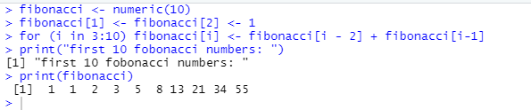

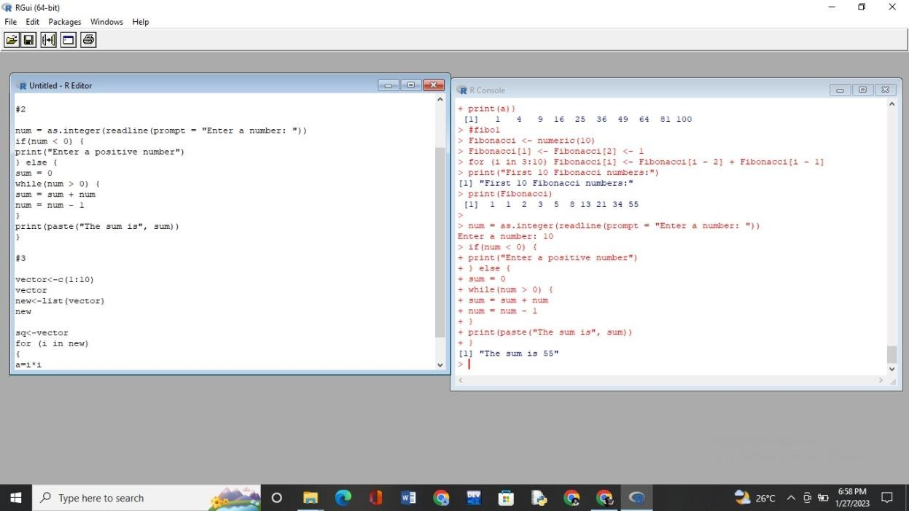(ii) Find sum of natural numbers up-to 10, without formula using loop statement.



      
      
      
      
      

